Required Components
       | 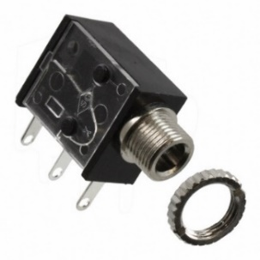 | BOM  - Kid Connection Bulldog, Cat, Unicorn, or Dinosaur Walking Pet  - 3.5mm Mono Jack and Nut (x2)  - 22 AWG Wire  - AA Batteries (x2)  Refer to the Tool and Component List for purchasing details.
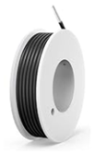 | 

Required Tools
- Phillips screwdriver
- Wire strippers
- Soldering iron and solder
- Drill and ¼” drill bit

Required Personal Protective Equipment (PPE)
- Safety glasses

Assembly Instructions

- Locate the three screw holes on the leash that are hidden underneath the paper logo. Use a screwdriver to poke through the paper and reveal the screws. Remove the screws and open the leash handle. Keep the screws in a safe place. | 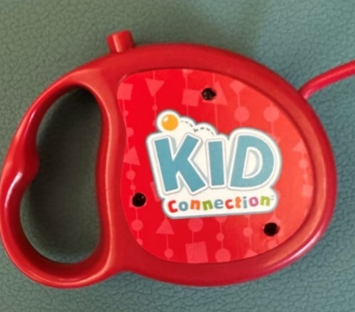  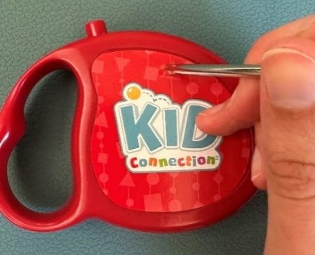
- Open the leash handle. We will be working on the half that has the pcb and buttons. Remove the pcb and button cover from the leash handle. | 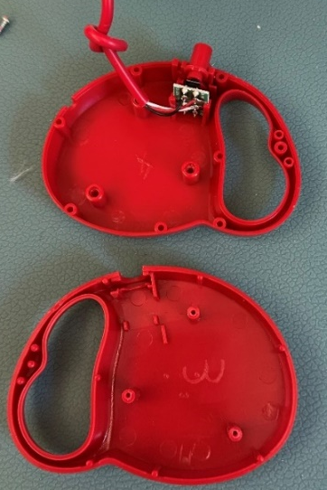  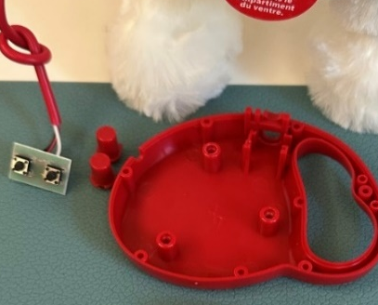
- Using a drill with a ¼’’ drill bit, drill two holes in the back part of the leash handle on the bottom as shown in the image. These holes are for the mono jacks, so ensure there is enough space for the mono jacks to sit inside the leash handle. Try to put the mono jacks through the holes to make sure they fit. | 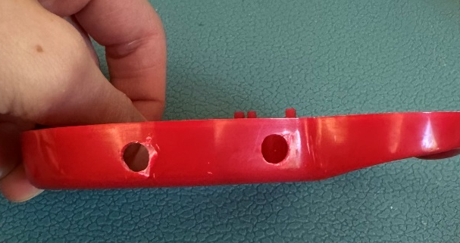
- Cut four pieces of wire 3 inches long | 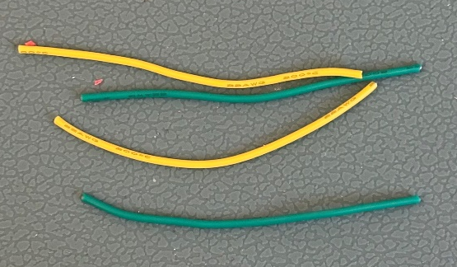
- Strip approximately 0.5 cm off the ends of each wire. | 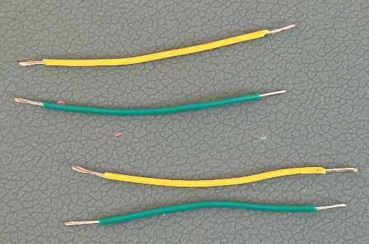  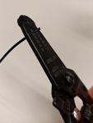
- Tin one end of each wire. Do this by melting a small amount of solder to cover the exposed wire. Do this to all four wires. | 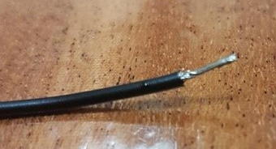
- Solder two of the prepared wires to the two spots shown in the image to the right.  Note: Do not solder the wires straight down, since the pcb will be placed back in the leash handle vertically. Make sure the wires are oriented up, towards the middle of the pcb as shown in the image | 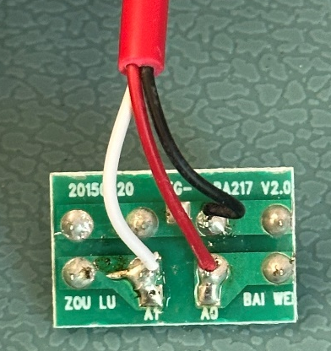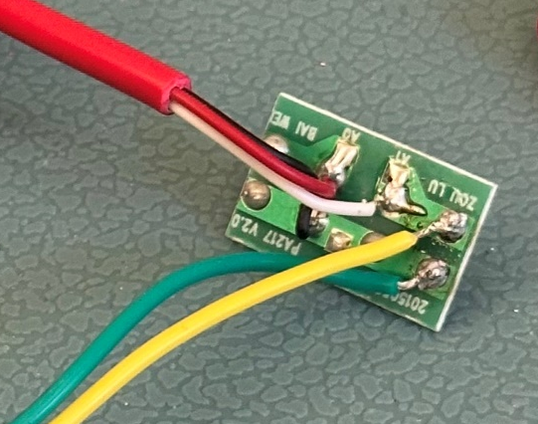
- Solder the other ends of these two wires onto the mono jack – feed the wires through the holes on the prongs, and fold over. Then solder the connection. Only use the two prongs closest to the jack. | 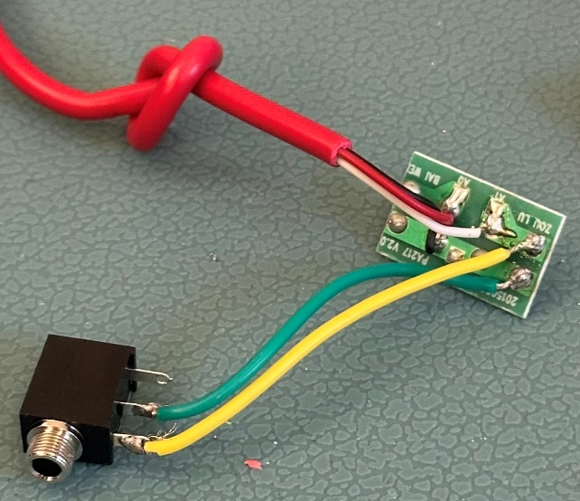
- Solder the other two prepared wires to the spots on the pcb circled in blue as shown in the image.

Again, the wires should be oriented towards the middle of the pcb. NOT straight out. See step 10 image.
- The pcb should look like this now | 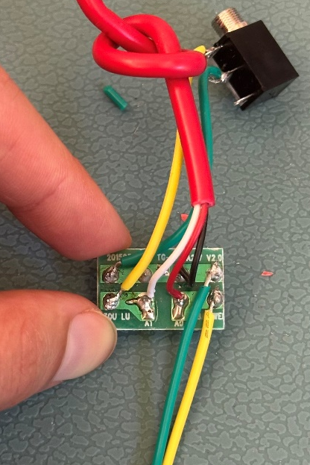
- Put the PCB back in the leash handle with the button cover on top. Make sure the labels on the button cover correspond to the proper functions. | 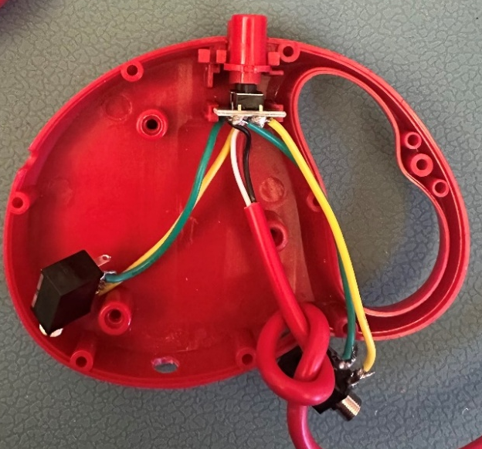
- Test the toy with two assistive switches. If the toy does not work, check soldered connections | 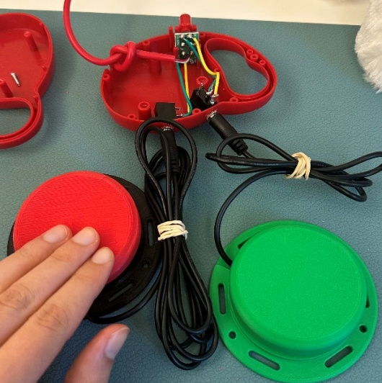
- Place the mono jacks through the two drilled holes. Secure them by tightening the retaining ring on the outside of the toy. | 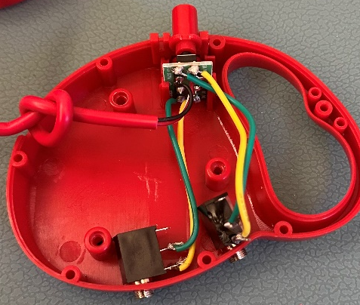  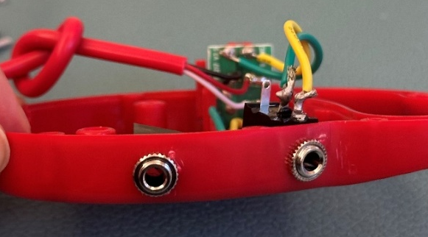
- Close the leash handle. Make sure the leash cable goes through the slot in the handle with the knot staying inside the handle before closing.  Tighten the screws. | 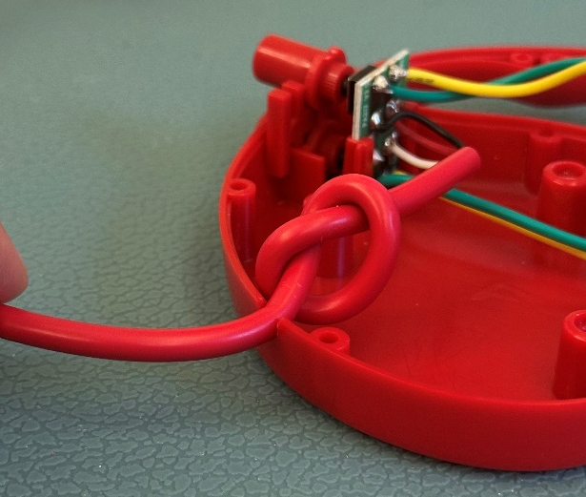  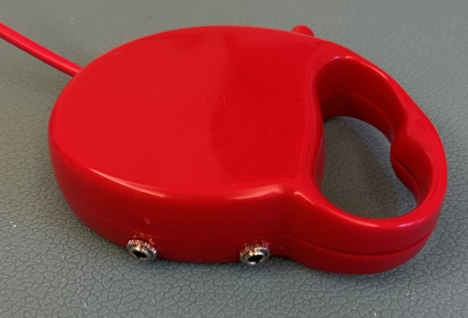
- Test the toy with two assistive switches. The toy is done! | 